A new outlook on “What I Eat in a Day”

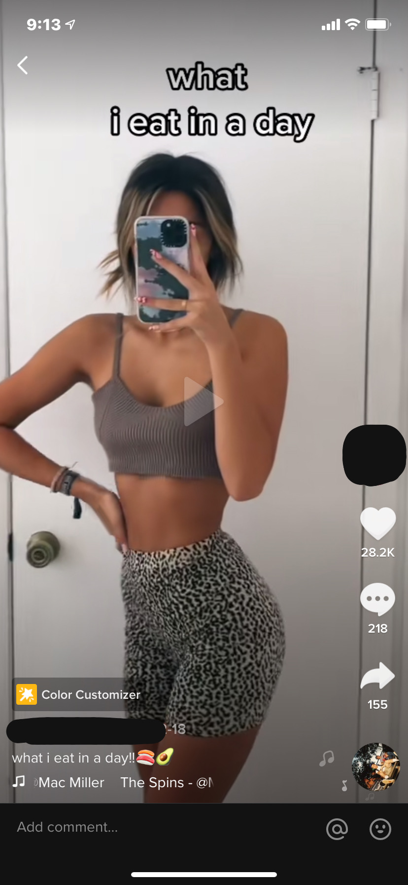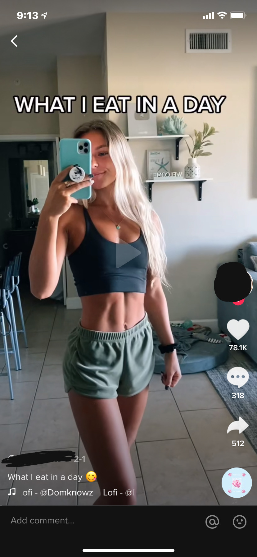

Social media has a huge impact on body image. The newest (and widely popular) app, TikTok, has influenced the health and well-being of many of its users. Sure, there are influencers that promote healthy lifestyles with protein packed meals and exercise regimens to gain muscle and not just lose weight. But a lot of popular women on TikTok participate in the new phenomenon of “what I eat in a day” videos, which have inadvertently encouraged their followers to think their three meals a day should be a granola bar, salad, and well… another salad.

\*I’m not personally attacking the women I chose as examples-- I am sure they have zero intention to harm their viewers. However, these videos in general and how they begin them by showing their perfect bodies shows the issue behind these “what I eat in a day” videos.

Due to COVID-19, people are spending a lot more time on their phones and especially on Tiktok. According to business insider, Tiktok has more than 2.3 billion downloads and 100 million in the United States alone. In addition, Wallaroo Media, a marketing agency, estimated that Tiktok would have grown to more than 1.1 billion users as of February 2021; we are now at March and this number has more than doubled. Conclusively, this video-sharing social media app has gone viral and is popular around the world.

Over this past winter break, I got into a cycle of hyper focusing on my looks and I do think these videos played a big role in causing that. I felt like if I didn’t work-out every day I would gain weight and I watched what I ate a lot more than I used to. Seeing what a “perfect” model, or anyone with body privilege, eats in a day starts to convince users that if they eat like them, they’ll look like them. Even worse, it instills comparison which leads to negative self-talk.

The deadly side of comparison is present now more than ever with the increase of importance of social media in young adults' lives. Prior to Instagram and Tiktok, “healthy-living” influencers reached their audience through blog posts and websites. In order to be a successful blogger, you have to publish several blog posts a day and it takes longer to reach a large audience. The possibilities of Instagram heighten that outreach-- and Tiktok skyrockets it. The unique part of Tiktok is that *anyone* can go viral for no apparent reason, unlike blogging and Instagram which take more work to build a bigger audience. The problem with this is that there is a lack of control in what you follow and the content you see each day. On Instagram, if you follow an influencer whose niche is health, you are aware of the information you are exposing yourself to and you have the choice to unfollow them if you don’t wish to see their posts anymore. However, on Tiktok, sure, you can say you’re “not interested” on a post, but there’s a much greater chance of seeing that same post again and being negatively affected by it. The repetition of this promotion of unhealthy eating habits is why the problem snowballs and affects a vulnerable audience of self-assessing young adults.

As a 19-year-old female on Tiktok, I enjoy watching health-oriented material so these “what I eat in a day” videos are constantly on my foryoupage. The foryoupage is personalized for each user based on what you interact with the most-- whether that be liking, commenting, sharing, or watching the whole video. It gives you the most accurate stream of videos that you would be interested in. Health experts have been condemning these posts for causing disordered eating and unhealthy comparison to other people's lifestyles. I saw first-hand how this happens. I lost confidence. I saw friends develop body dysmorphia and engage in disordered eating. The topic of ‘what I eat on a day’ videos kept coming up in our conversations.

On the other hand, there are influencers using their platform to help others who struggle with eating disorders or who just want to help their followers eat normally and not restrictively. For example, videos titled “let’s eat together” have emerged wherein the creator pretends to eat with the viewer and prompts them to take a bite of their food. Many viewers struggling with eating disorders have even “dueted” these videos and their reaction is very powerful.

Personally, I wish that there would be more influencers focused strictly on fitness. Eating is a huge part of health, but it’s a very fragile topic and should be between a person and their healthcare provider. Social media has normalized taking in random people's eating habits (who may not even have credentials) and implementing them into their own daily lives, without taking into account their body’s unique needs. But exercise is both beneficial for the body and the mind. Exercise has many mental health benefits. When exercising, the body releases endorphins and serotonin that improve mood. It can also release stress and help improve your sleep. To me, seeing a workout video on TikTok inspires me to get up and get moving. “What I eat in a day” videos only cause me to compare myself to the creator and go inward.

Health isn’t just about putting good food in your body or doing a killer workout-- it’s about *everything* that you put into you. For me, happiness is key to health and doing anything that takes me out of myself-- whether that is doing an activity to just get out of my own head, like taking a walk or watching the sunset, or doing something to help others---does the trick. Throughout the past year I have been sporadically working on an Instagram page, other than my personal, that captures these moments and promotes confidence and selflove. My most recent posts have been about my experience while on Accutane for acne (which I just finished). It’s been beneficial for me because it felt good to help others going through the same thing. For those not struggling with acne, the posts build others’ confidence by sharing vulnerabilities, conveying the message that nobody’s life is perfect, and everyone has their own inner struggles. My “motto” behind my page is that our flaws are what makes each of us beautiful, interesting, and unique. I’ve even had some of my followers reach out to me through Instagram dm’s to ask me about my experience, which is the most rewarding part of my page.

I decided to make my own version of the “what I eat in a day” Tiktoks with a play on words. I decided to film all the little moments throughout my day that make me the happiest and give me fulfillment. It made me appreciate the little things in life like watching the sunset or walking through the snow.